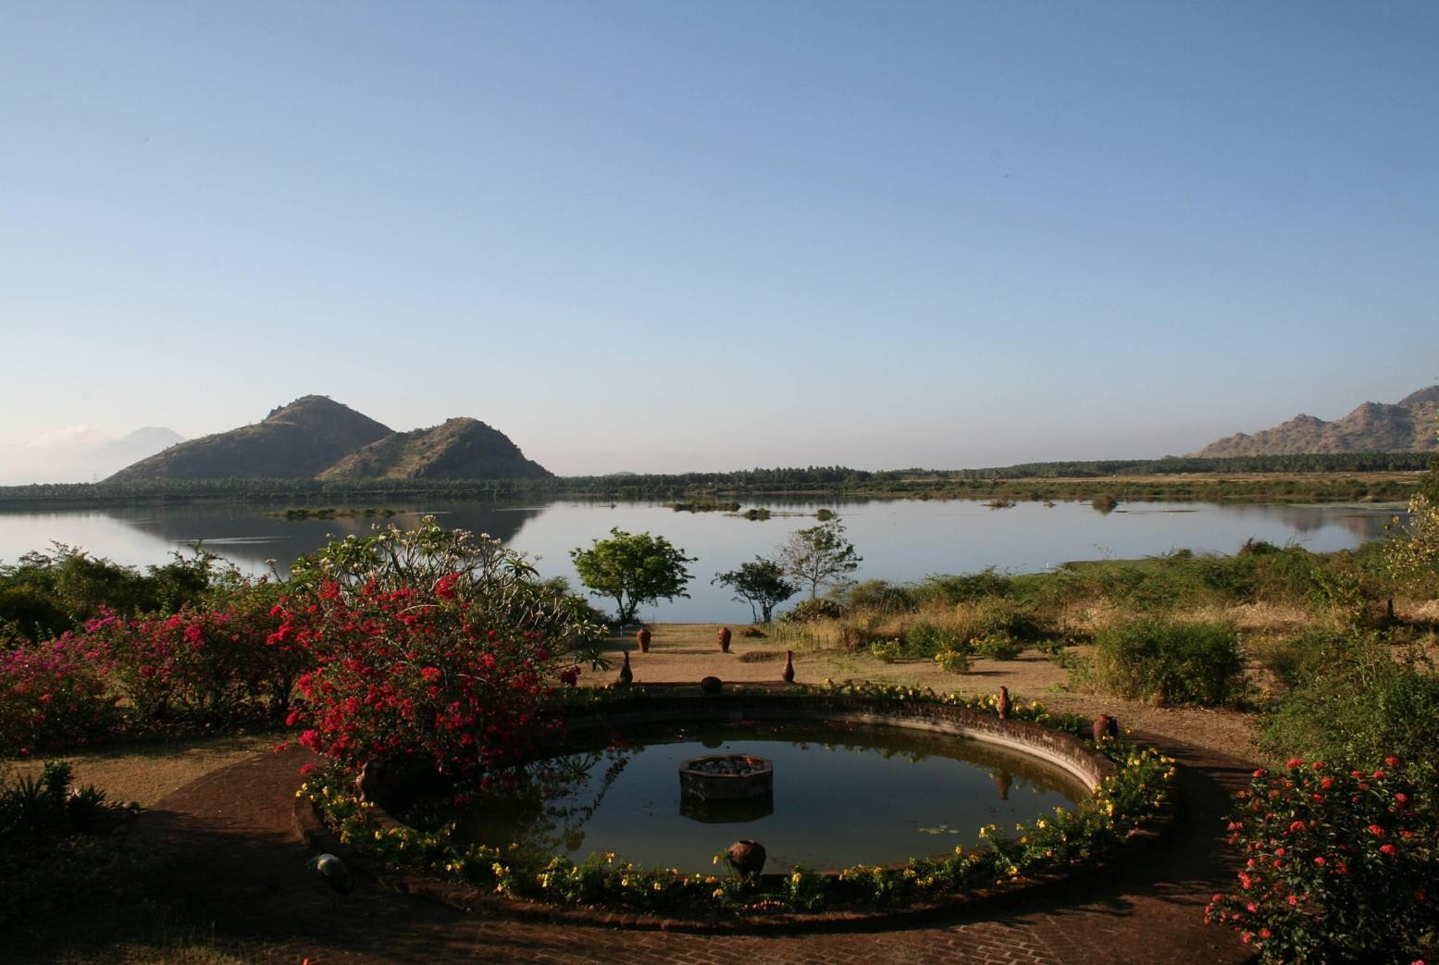
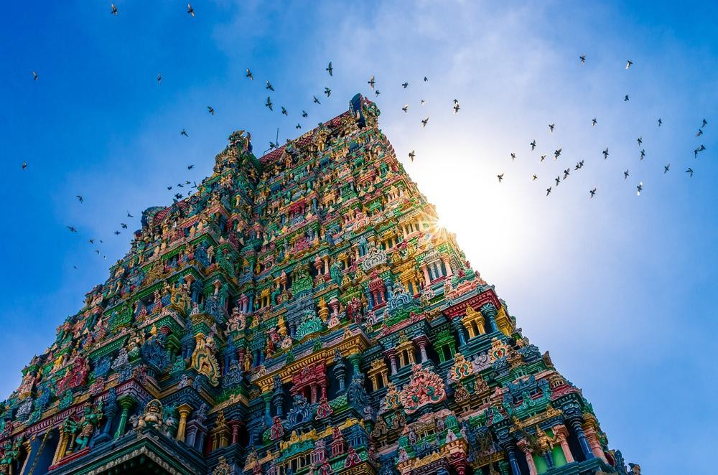
Tel: + 91 44 2744 3260 / 3360 / 2460
Fax: 91 44 2744 2160
Email: southindia@travel-xs.com Web: www.travel-xs.com

Cultural Tour of South India

BANGALORE – MYSORE – WAYANAD - COCHIN – ALLEPPEY – PERIYAR – MADURAI – ATHOOR – TANJORE – PONDICHERRY - MAMALLAPURAM – CHENNAI

TOUR DAYS: 14 Nights and 15 Days
Bangalore (Arrival) – Mysore – Wayanad – Cochin – Alleppey – Periyar – Madurai – Athoor – Tanjore – Pondicherry – Mamallapuram - Chennai (Departure)

PACKAGE COST: Minimum 8 pax (01 Oct – 20 Dec / 15 Jan – 31 Mar’19) Package cost per person on twin sharing - EURO 1390 / person Single Supplement Charge - EURO 495 / person

TOUR LODGING INFO: 14 Nights Hotel
Accommodation is provided in twin room on daily breakfast basis. For lunch and dinner there would be an additional supplement. Find below the hotel list:
PLACE | DAY | NO. OF NTS | HOTEL
Mysore | 01 – 03 | 02 | Sandesh The Prince
Wayanad | 03 – 05 | 02 | The Mint Flower
Cochin | 05 – 07 | 02 | Fort Manor
Alleppey | 07 – 08 | 01 | Houseboat
Periyar | 08 – 10 | 02 | Jungle Resort
Madurai | 10 – 12 | 02 | Madurai Residency
Athoor | 12 – 13 | 01 | Double Dutch Resort
Tanjore | 13 – 15 | 02 | Laxmi Hotel
Pondicherry | 15 – 16 | 01 | Abhirami Residency
Mamallapuram | 16 – 18 | 02 | Mamalla Heritage

PACKAGE COST INCLUDES:
- Accommodation in a double room on daily breakfast basis in above mentioned hotels (or) equivalent
- Transport by air-conditioned vehicle
- Train from Calicut to Cochin
- One night stay in Houseboat including all meals
- Sunset cruise at Cochin
- Trekking at Periyar
- Taste the local savouries at Mysore
- Old City Walk at Madurai
- English speaking tour escort
- Cycle tour of Pondicherry
- Auto Rickshaw tour of Kadumbadi
- All currently applicable government taxes

PACKAGE COST EXCLUDES:
- Meals other than those specified in the itinerary
- Entrance fees at all sightseeing spots, Camera fee, Special guide charges & tips
- Things of personal nature like laundry, telephone etc.
- International flight charges if any
- All other than those listed in above inclusions

PRICE INFO AND VALIDITY:
- The above quote is valid for 08 paying persons only

TOUR ITINERARY:

DAY 01: BANGALORE TO MYSORE (140 Km /4.5 hr)
Morning pickup from Bangalore hotel and drive to Mysore steeped in History, Mysore - the adobe of untold grandeur and glory - is where the rich heritage of the Wodeyar Kings is carefully preserved to this day in its magnificent palaces, beautifully laid-out gardens, imposing buildings, broad shady avenues and sacred temples. There's an old world charm about the city. Built in Indo-Saracenic style with domes, turrets, arches and colonnades, the Palace is a treasure house of exquisite carvings and works of art from all over the world.

On arrival check in and relax. Overnight stay at Mysore.

DAY 02: MYSORE
Morning proceed for heritage walk of Mysore, pass by some grand old structures and unfold the story of Mysore. Learn about the opulent lives of the Maharajas and how one of the richest men on the planet lived.

Evening explore a century old market and immerse yourself in the vibrancy and colors. And taste the local savouries Mysore Pak, Mysore Masala Dosa, Mysore Churumuri the list goes on with gastronomical delights from the city. If you are a foodie then Mysore spoils you with its wide variety options. Now who doesn’t enjoy some good food especially when there is so much out there to choose from and mind you, we take all matters related to food quite seriously! Overnight night at Mysore.

DAY 03: MYSORE TO WAYANAD
Morning Check-out from resort and drive to Wayanad set in the picturesque Western Ghats and mountains at an altitude of about 2000 meters above sea level. Littered with tropical rain forests, dense hills, rolling paddy fields, spice plantations and valleys, Wayanad is a hitherto undiscovered location offering breathtaking views. On arrival check in for overnight stay. (Overnight stay in Wayanad)

DAY 04: WAYANAD
Free day to relax and explore the nature’s beauty. Overnight stay in Wayanad.

DAY 05: WAYANAD TO COCHIN:
Morning checkout and drive to Calicut railway station for train to Cochin, on arrival transfer to Hotel. Overnight stay at Cochin.

DAY 06: COCHIN: A Visit to Fort Kochi and Sunset cruise

After breakfast, proceed to Fort Kochi for a guided tour. Wander through the old districts of Mattancherry and Fort Cochin, where the various European influences are most apparent in the merchant houses and old warehouses, cramming the waterfront and narrow streets. Explore the Paradesi Synagogue in Jew Town, (closed on Friday & Saturday), St Francis Church - the oldest European church in India, the 16th century Dutch Palace and the much-photographed Chinese nets.

At sundown, set sail on a two hour Sunset Cruise, at the beautiful fishing harbor of Vypin and picturesque islands of Fort Kochi.

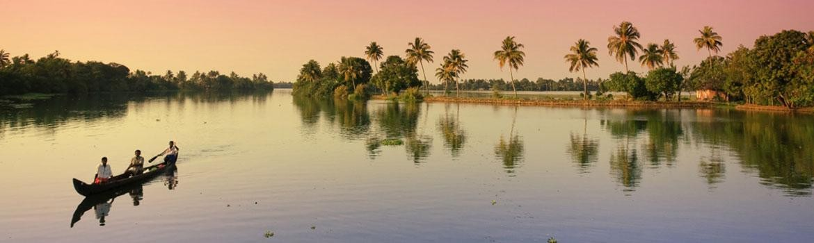

DAY 07: COCHIN TO ALLEPPEY (65 Km / 1.5 hr)
Morning checkout and drive to Alleppey – The Land of Backwaters. On arrival, embark into a private House Boat at 12.30 hrs. Houseboat cruise is the best way to explore the beauty of backwaters. Enjoy rest of the day at leisure on the House Boat. Sit back and relax while the boat cruises through the serene backwaters. Lunch, Evening Tea/Coffee with snacks, dinner and enjoy your evening away from polluted cities and maddening crowd. Prior to sunset your boat will come to rest along the shores in a spot where you can watch the colorful sky closing out the day and transitioning into evening. Only disturbance will be twinkle of a shining star or diving of a fish around you to say hello by waving its tail from the lake. (Overnight in houseboat on full board basis)

DAY 08: ALLEPPEY TO PERIYAR
Disembark from houseboat and drive to Periyar or Thekkady is located in Idukki district. The very sound of the name conjures up images of elephants, unending chains of hills and spice scented plantations. Here, in the crisp, cool air of the Western Ghats you will experience the most enchanting holiday. In the Periyar forests of Thekkady is one of the finest wildlife reserves in India, and spread across the entire district are picturesque plantations and hill towns that hold great opportunities for treks and mountain walks. On arrival check into hotel and relax. (Overnight stay in Periyar)

DAY 09: PERIYAR
Today at 07:00 am – Trekking in Periyar. This is a conservation-oriented 3 hours trek covering 05km. The route passes through undulating terrains. Altitudinal ranges of 900 meters to 1300 meters will be covered and trekkers obtain glimpses of the lofty escarpments bordering the park watershed and the vast plains down below. Gaur sloth bear, elephant etc. are often sighted along this route apart from birds and butterflies. The trekkers will go with an English speaking guide. (Overnight stay in Periyar)

Intensity Level of Nature Walks: High levels of fitness are not required to do this program. However, you need to be in general good health and used to walking

DAY 10: PERIYAR TO MADURAI: A Rickshaw tour of Colorful Madurai. (160 km /4 hrs)

Travel to the temple town of Madurai. This vast, pulsating city is one of the oldest cities in South India, dating back 2500 years, and sprawls along the banks of the River Vaigai. Wander through the fun, packed streets, full of pilgrims, wandering cows, open-air kitchens and colorful bazaars.

After lunch, you will then take a rickshaw tour, to explore Multicolored Madurai. During this tour, you are going to explore the famous banana market of Madurai, the cotton weaving industry, the vibrant vegetable markets and the Gandhi Memorial Museum.

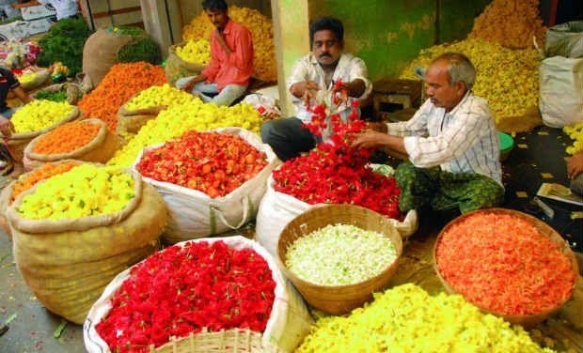

DAY 11: MADURAI: A Visit to Meenakshi Temple
You get an opportunity to wander around the tailor markets and bazaars before visiting the Sri Meenakshi Temple. This ancient temple is a maze of lamp-lit corridors. You will always find something that takes place here – ceremonies, musicians playing, weddings, prostrating pilgrims and festivals – making it a compelling place to spend time and enjoy the sights of a typical temple life. The next stop is the Thirumalai Nayak Palace, an example of architectural grandeur. It was built by King Thirumalai Nayak in 1636 AD. The palace was designed by an Italian Architect and served as the residence of the King.

In the evening you can then attend the Night Ceremony, a highlight at the Meenakshi Temple (optional). An image of Lord Shiva is carried out from his shrine by temple priests, in procession in a chariot, to his wife, Meenakshi's shrine, where he spends the night and a ceremonial puja (worship) is performed, amidst much chanting, drums, horns, and smoke.
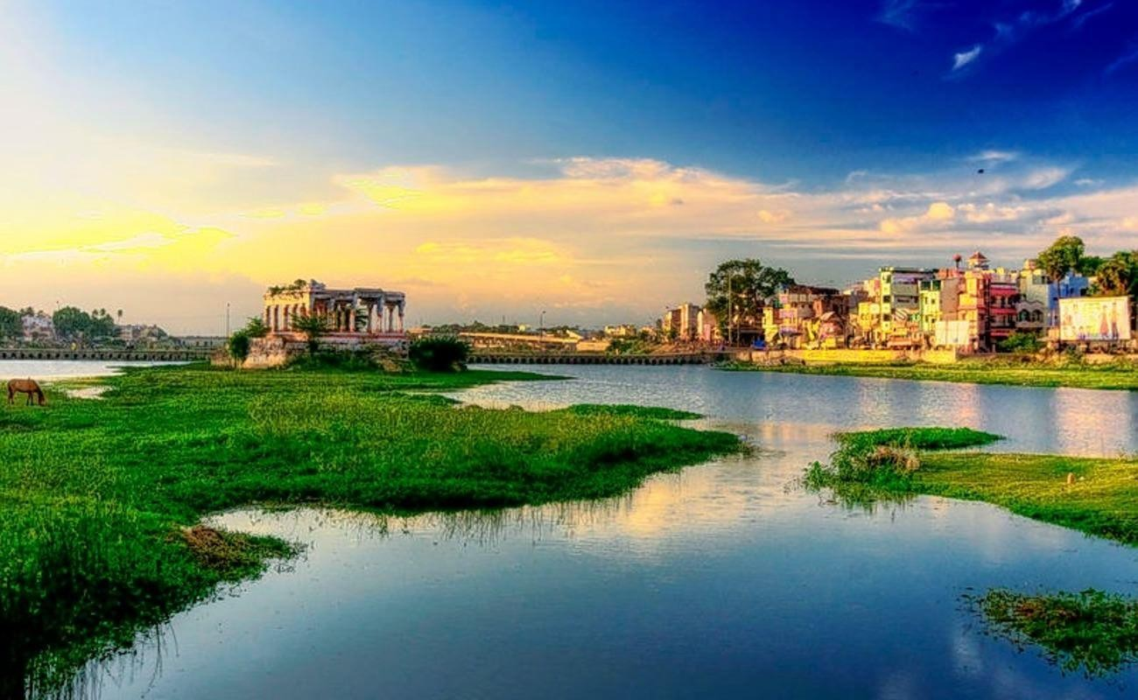

DAY 12: MADURAI TO ATHOOR: Bird watching and Village walk. (60 km /1 hr)
After breakfast, proceed to Athoor Village, located on the lap of nature. Athoor is an ideal place for relaxation and contemplation. Kamarajar Dam at Kamarajar Lake is a 400-acre monsoon-fed water body, 6 km West from Athoor village. This lake is set at a beautiful location with the hills of the Western Ghats overlooking it. Fishermen in their coracles on the lake, and coconut and banana plantations and cardamom estates are the common sights on the surrounding hills. This natural site, is a perfect place for bird watching and a Village walk. You will be assisted by a local guide during the course of these activities.
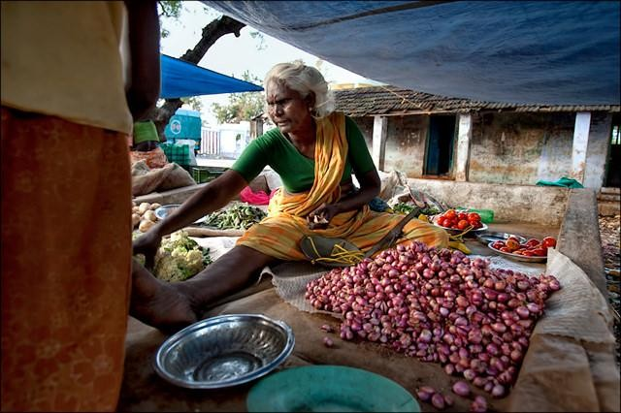

DAY 13: ATHOOR TO TANJORE via KARAIKUDI.
The day starts with a drive to Tanjore. On the way, you can stop at Karaikudi/Chettinadu, a city known for its elegant mansions, highlighting the best of the region's art and architecture. Karaikudi is also famous for its mouthwatering cuisine. So enjoy an authentic Chettinad lunch, which is best sampled in the elegant ambience it deserves- like the banquet hall.

You can then proceed towards Tanjore. A bustling market town, in one of the main rice-growing regions of Tamil Nadu, Tanjore was once the capital of the Chola empire and though, many structures from that period no longer survive, the town still boasts of its lovely temples.

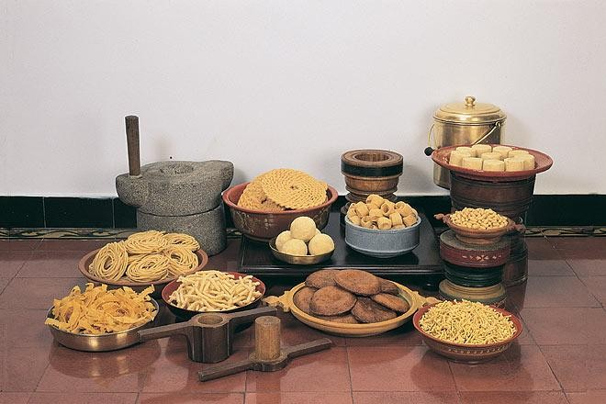

DAY 14: TANJORE: Exploring the City.
Your day starts with a tour of the Brihadeshvara Temple. This magnificent temple, over 1000 years old, and now a UNESCO World Heritage Site, evokes the power of the Chola kings, as it towers over the town.

Our next stop is at The Thanjavur Art Gallery. This gallery was built in the beautiful Thanjavur Royal Palace of the Nayaks in 1600 A.D. The walls of the art gallery, adorn painting and sculptures of South India that prevailed during the peak of the Tamil history.

Then we proceed to the village to explore bronze casting and Tanjore paintings. With a history of traditional bronze casting, take the opportunity to view the masters at work using the lost-wax method. This method, used to create sacred temple bronzes during the Chola period, is still practised today and is being passed down through the generations, to ensure that bronze casting continues to thrive.

In the evening, feel free to explore the vibrant market roads of Tanjore, or you can even enjoy a local movie for an Indian Theater experience.

DAY 15: TANJORE TO PONDICHERRY: (160 kms /4 hrs)
After breakfast, head out to Pondicherry. Attractively set on the Bay of Bengal, with delightful unspoilt beaches, this surprising town is a throwback to colonial times, when it was a French enclave, but nowadays it is richly blended with Tamil culture. Those, used to British colonial architecture will enjoy the Gallic imprint, with the profusion of Catholic churches and distinctly French buildings, such as the beachfront Hotel de Ville and excellent French restaurants.

In the evening, explore this beautiful town on a bi-cycle and visit places like The Shri Aurobindo Ashram, the Church of our Lady of the Immaculate Conception, or the Hindu temple of Lord Ganesh, whose walls are embellished with a wonderful series of paintings of Ganesh in various forms.

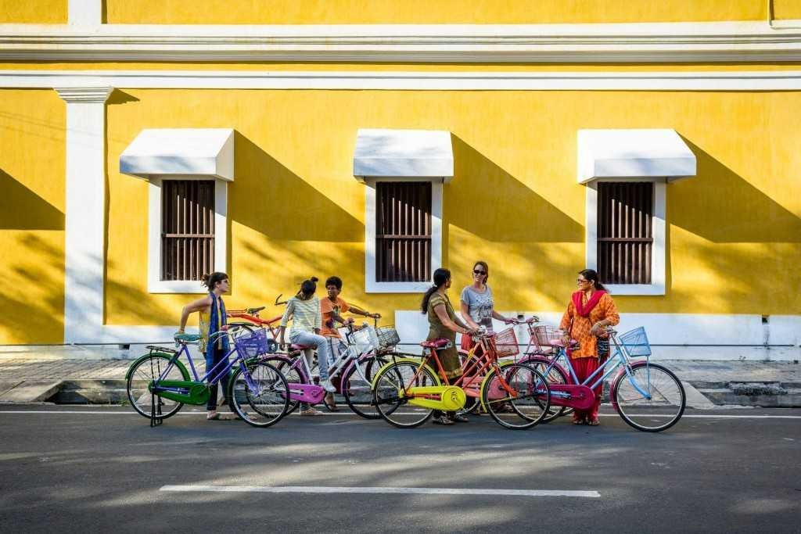

DAY 16: PONDICHERRY to MAMALLAPURAM (100 kms /2 hrs)
Drive on to Mamallapuram. On the way you can visit the harmonious community of Auroville, inspired by The Mother, where people can come together, regardless of nationality, belief or colour, to live a meaningful life.

Mahabalipuram - Seventh and eighth-century reliefs, rock and cave temples as well as "chariot" temples, carved into the golden stone of the Coromandel Coast have made Mahabalipuram, also known as Mamallapuram, an astonishing UNESCO World Heritage Site.

After check in, you can choose to walk through the history of Mamallapuram. Each of the cave temples, monolithic chariots, sculpted reliefs and structural temples, has its own story to tell. The 7th Century town, which boasts of the oldest existing remains of the Dravidian architecture, will have your hearts captured with its quaint beauty and timeless stories.

DAY 17: MAMALLAPURAM: Village tour of the town
In the morning, you will participate in a village tour by Auto Rickshaw – Villages are the best places to learn about the Indian culture and tradition. Maybe that’s the reason why Gandhi said, "Villages are the heart of our nation". This tour on an auto rickshaw - the famous hooded three- wheeler of India, covers a trip around the village, where you can enjoy the sights of little mud huts with outdoor kitchens, village panchayat schools - where classes are sometimes conducted under the shade of a tree, little temples, pottery sites where one is able to listen to a tale or two as the potter spins the wheel, and lush green agricultural fields to experience an authentic Indian village. Enjoy your lunch in a local house / local restaurant. Free Afternoon to be spent as desired.
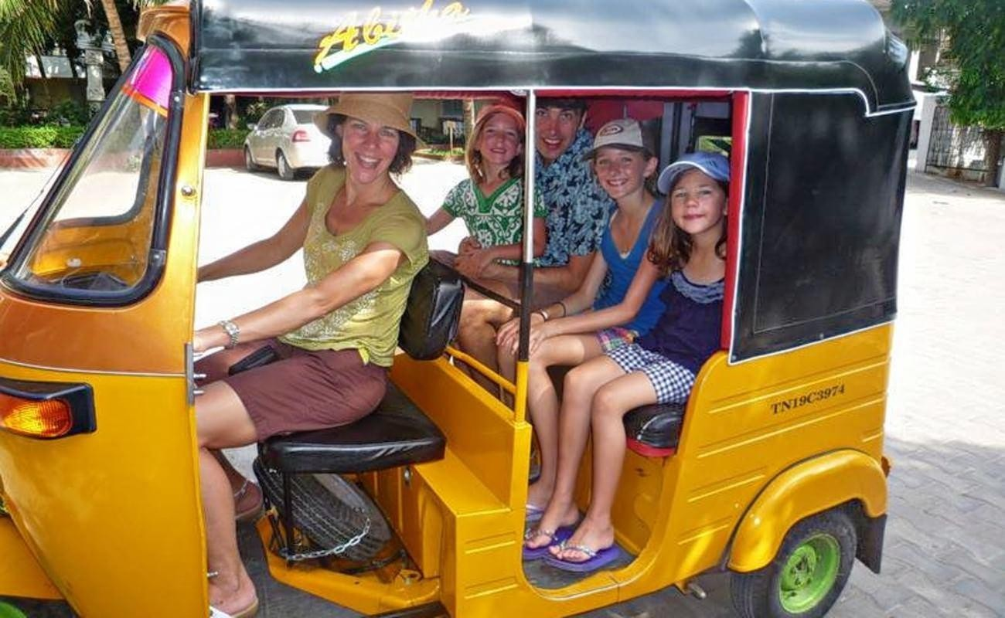

DAY 18: DEPARTURE
After breakfast it's time to bid farewell to South India. You will be dropped at the Chennai airport to connect your onward flight.

-END OF SERVICE-

